**InnoDB Storage Engine architecture:**

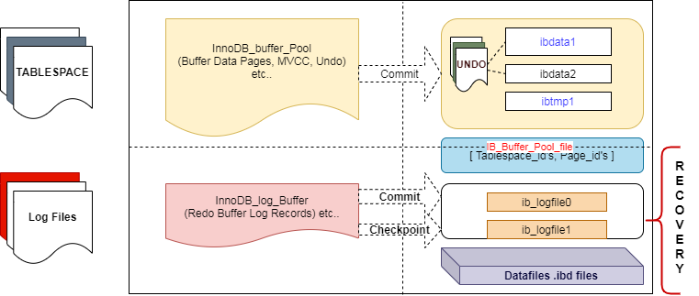

**Tablespace:**

Storage for InnoDB is divided into tablespaces. A tablespace is a logical structure associated with multiple data files(objects). Each tablespace contains pages(blocks),extents and segments.

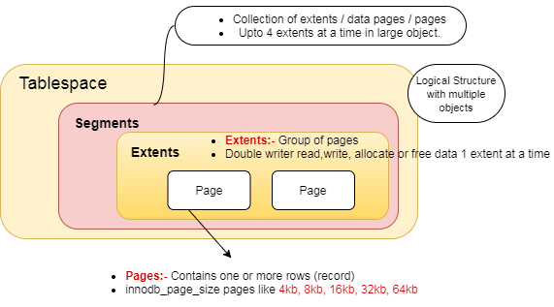

**Pages:** a Smallest piece of data for InnoDB also called as blocks. **Default page size is 16kb and page can hold one or more rows depending on row size.**

Available page sizes: 4kb,8kb,16kb,32kb,64kb  
Variable name           : **innodb_page_size**  
Need  to configure before initializing mysqld server.

**Extents:**  It’s a group of pages.For better I/O throughput innodb read or write a collection of pages i.e one extent at a time.  
For a group of pages with default page size 16kb, extent size up to 1mb.  
Doublewrite buffer read/write/allocate or free data as one extent at a time.

**Segments:**  Collection of files in InnoDB tablespace.Use up to 4 extents in a segment.

Show variables like 'innodb_page_size';

**Creating Tablespace introduced in MySQL 5.7 Version**

Creating General Tablespace

SELECT TABLESPACE_NAME,FILE_NAME FROM INFORMATION_SCHEMA.FILES;

mysql> CREATE TABLESPACE `bigtbs` ADD DATAFILE '/var/lib/mysql/bigtbs1.ibd' engine=Innodb;

Query OK, 0 rows affected (0,00 sec)

CREATE TABLE test_1 (id int(11), c_desc varchar(100), c_comments text ) TABLESPACE bigtbs;

CREATE TABLE EMP(ID INT,NAME varchar(30)) ;

insert into EMP values (1,'venkat');

insert into EMP values (2,'priya');

CREATE TABLE dbacentre(id int, course varchar(100), city varchar(100) ) TABLESPACE bigtbs;

Insert into dbacentre values(1,'mysql dba','bangalore');

Insert into dbacentre values(2,'sql dba','bangalore');

Insert into dbacentre values(3,'oracle dba','bangalore');

Insert into dbacentre values(4,'oracle rac dba','bangalore');

mysql> show create table dbacentre;

mysql> create table dbatbs like sbtest1;

Query OK, 0 rows affected (0,01 sec)

mysql> insert into dbatbs select * from sbtest1;

Query OK, 25661594 rows affected (7 min 52,96 sec)

Records: 25661594 Duplicates: 0 Warnings: 0

mysql> alter table dbatbs tablespace = dbatbs;

Query OK, 0 rows affected (2 min 41,21 sec)

Records: 0 Duplicates: 0 Warnings: 0

[root@mysql-57 ~]# ls -lh /var/lib/mysql | grep dbatbs

-rw-r-----. 1 mysql mysql 6,7G ??? 8 06:40 dbatbs.ibd

mysql> CREATE TABLESPACE `business` ADD DATAFILE '/var/lib/mysql/business1.ibd' engine=InnoDB;

mysql> CREATE TABLESPACE `economy` ADD DATAFILE 'econmoy1.ibd' engine=InnoDB;

--Will Create tablespase with 8kb

CREATE TABLESPACE `ts8kb` ADD DATAFILE '/var/lib/mysql/ts8kb.ibd' FILE_BLOCK_SIZE = 8192 ENGINE=INNODB;

Create table ts8(id int,name char(20)) tablespace ts8kb;

CREATE TABLESPACE `ts4kb` ADD DATAFILE '/var/lib/mysql/ts4kb.ibd' FILE_BLOCK_SIZE = 4096 ENGINE=INNODB;

Create table ts4(id int,name char(20)) tablespace ts4kb;

CREATE TABLESPACE `ts32kb` ADD DATAFILE '/var/lib/mysql/ts32kb.ibd' FILE_BLOCK_SIZE = 32768 ENGINE=INNODB;

CREATE TABLE test99 (c1 INT PRIMARY KEY) TABLESPACE ts2 ROW_FORMAT=COMPRESSED KEY_BLOCK_SIZE=8;

CREATE TABLE emp9 (id INT,name varchar(30),city char(30)) TABLESPACE ts8kb KEY_BLOCK_SIZE=8;

CREATE TABLESPACE `mytbs` ADD DATAFILE '/var/lib/mysql/mytbs1.ibd' engine=Myisam;

ERROR 1478 (HY000): Table storage engine 'MyISAM' does not support the create option 'TABLESPACE or LOGFILE GROUP'

----trying with 32kb

mysql> CREATE TABLESPACE `ts32kb` ADD DATAFILE '/var/lib/mysql/ts2.ibd' FILE_BLOCK_SIZE = 32768 ENGINE=INNODB;

ERROR 1478 (HY000): InnoDB: Cannot create a tablespace with FILE_BLOCK_SIZE=32768 because INNODB_PAGE_SIZE=16384.

mysql> CREATE TABLESPACE `ts4kb` ADD DATAFILE '/var/lib/mysql/ts4kb.ibd' FILE_BLOCK_SIZE = 4096 ENGINE=INNODB;

select * from INFORMATION_SCHEMA.FILES where TABLESPACE_NAME ='general'\G

or

SELECT TABLESPACE_NAME,FILE_NAME FROM INFORMATION_SCHEMA.FILES;

Existing table into general tablespace.

mysql> create table innodb_table (id int (11), uname varchar(78));

Query OK, 0 rows affected (0.01 sec)

mysql> insert into innodb_table values(1,'moving to dba tbs');

Query OK, 1 row affected (0.01 sec)

mysql> ALTER TABLE innodb_table TABLESPACE dbatbs;

Query OK, 0 rows affected (0.02 sec)

Records: 0 Duplicates: 0 Warnings: 0

mysql>CREATE TABLESPACE `sbtest3` ADD DATAFILE '/var/lib/mysql/sbtest3.ibd' engine=InnoDB;

Query OK, 0 rows affected (0,02 sec)

mysql> alter table dbatbs tablespace = sbtest3;

Query OK, 0 rows affected (3 min 23,50 sec)

Records: 0 Duplicates: 0 Warnings: 0

# dropping old tablespace

mysql> drop tablespace bigtbs;

Query OK, 0 rows affected (0,13 sec)

There should be sbtest3.isl file in MySQL datadir:

[root@mysql-57 mysql]# ls | grep sbtest3.isl

sbtest3.isl

Note:-

ALTER TABLESPACE is not supported by InnoDB.

mysql>alter TABLESPACE `bigtbs` ADD DATAFILE '/var/lib/mysql/bigtbs2.ibd'

mysql>CREATE TABLESPACE new ADD DATAFILE 'new.ibd' engine=InnoDB;

CREATE TABLESPACE `ts8k` ADD DATAFILE 'ts8k.ibd' FILE_BLOCK_SIZE = 8192 ENGINE=INNODB;

SELECT FILE_NAME, FILE_TYPE, LOGFILE_GROUP_NAME, STATUS, EXTRA FROM INFORMATION_SCHEMA.FILES WHERE TABLESPACE_NAME = 'ts2';

Note:- EXTRA it will says whether its cluster node or stand alone

**----Note:- In NDB Storage Engine**

CREATE LOGFILE GROUP myg1 ADD UNDOFILE 'myundo-1.dat' ENGINE=NDB;

mysql> CREATE LOGFILE GROUP myg1 ADD UNDOFILE 'myundo-1.dat' ENGINE=INNODB;

ERROR 1478 (HY000): Table storage engine 'InnoDB' does not support the create option 'LOGFILE GROUP'

show variables like '%innodb_file_per_table%'

select table_id,name,space_type from information_schema.innodb_sys_tables;

select * from information_schema.INNODB_SYS_DATAFILES;

SELECT table_name,TABLE_ROWS,CREATE_TIME,table_type FROM INFORMATION_SCHEMA.TABLES where TABLE_SCHEMA='bigdb';